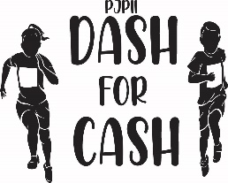

DASH FOR CASH
April / May

PRE-EVENT VOLUNTEER OPPORTUNITIES: (Begins December/January)
- Administrative Support – Assist with preparation and stuffing of solicitation letters/brochures. Prepare, copy and prep signage for day of event. School copier available.
- Solicitors (Online) – Follow up with previous sponsors and advertisers via email or online donation portals. Script/template provided. Identify and cultivate relationships with new sponsors. Update Google doc tracking sheet. Chair will provide list and target dates for completion.
- Solicitors (Face to Face) - Follow up with previous retail and restaurant vendors face to face to secure donations/raffle items/door prizes. Identify and collect donations from new vendors. Update Google doc tracking sheet. Chair will provide list and target dates for completion.
- Runners – Pick up donations that have been committed by donors. Support Solicitors efforts.
- Event Signage Coordinator – Coordinate receipt of logos for signs and t-shirts and serve as liaison with outside printers / designers. Communication via email recommended.

DAY OF EVENT VOLUNTEER OPPORTUNITIES:
Event Day
- Assist with set up of snack and water tables
- Assist with set up of PA system.
- Assist with decorations.
- Assist with set-up of Dashing track.

At Event
- Assist with snacks for students.
- Assist with water re-fill station.
- Assist with lap counting.
- Assist trash collection.
- Assist with minor first-aid.

POST EVENT VOLUNTEER OPPORTUNITIES:
- Administrative Support – Assist with preparation and stuffing of thank you/tax letters to all donors. School copier available.

To learn more please contact: Event Chairs at: dash4cash@popejohnpaul2sch.org

